Engrade › Wikis › Engrade Free Gradebook Help › Create a Class
Engrade
4742 Likes
Options
Assign to ClassBookmarkPrint
Engrade Free Gradebook Help

Create a Class
1. To create a class, scroll over Classes in the top menu and then click Create New Class from the drop-down menu. You may also select + Create New Class from the Active Classes screen.
2. Enter a class name, school year, and grading period. Enter a grade level and subject area. Click the Next button to continue.
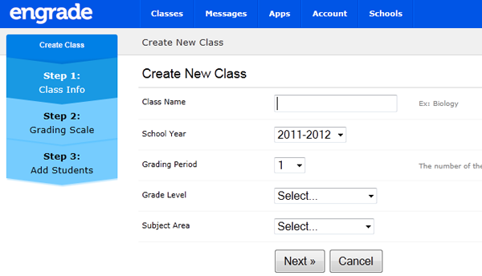
3. Enter your Grading Scale and Assignment Categories. You can modify these settings after you have created your class. Click the Next button to continue.
4. On the following page, you will create your class roster by entering students. This process differs depending on whether or not your teacher account is connected to your school's Engrade account.
Teachers Not Connected to a School:
When adding students, it is important to use a unique ID number for each student in your account. Please read this wiki on student ID numbers. It is highly recommended that you use your school's student ID numbers.
Be sure your students' names and ID numbers are entered into the box in the following format:
John Doe 3152353
Anne_Marie Jones 3145375
Sam de_la_Cruz 3155384
Notice that students with two or more first or last names should be entered with an underscore (_) between the names.
Teachers Connected to a School:
Adding students is a quick process when you are connected to a school. Select existing students from the school roster to add to your class. If you do not see a student in the school roster, contact your school administrator.
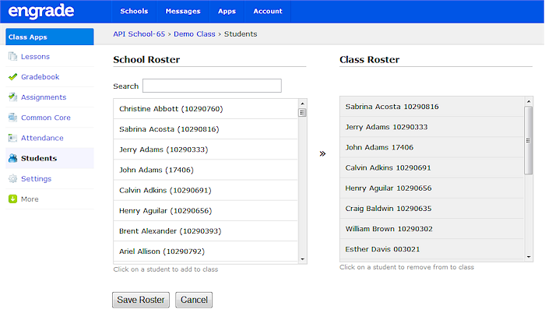

Edit Student Roster
Whether or not you are connected to an Engrade school account determines the method by which you will add students to your class rosters.

Not Connected to a School
If your teacher account is not connected to school account, you will need to create your own class rosters.
1. Select the name of the class for which you would like to update the class roster.
2. Select Students on the left sidebar.
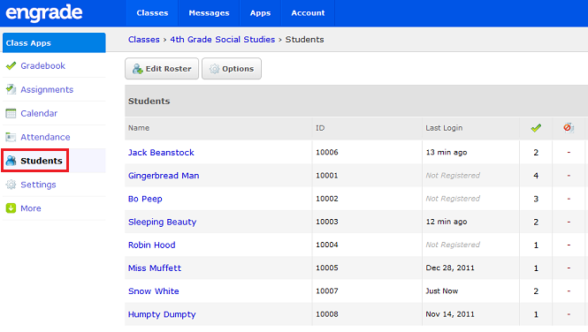
3. Click the Add Students button at the top of the page.
4. On the “Add Students” page, enter each student’s first name, last name and unique school ID number. Be sure your students' names and ID numbers are entered into the box in the following format:
John Doe 3152353
Anne_Marie Jones 3145375
Sam de_la_Cruz 3155384
Notice that students with two or more first or last names should be entered with an underscore (_) between the names. Please note: If you do not provide a student ID number following the students' first and last names, Engrade will automatically generate ID numbers for each student.
Click the Submit button to add the students to the selected class's roster.
5. If you need to remove a student from your class, find the student’s name on the Students page. Hover over the gear icon to the right of his/her name and select "Drop" from the drop-down menu. On the following page, click the "Submit" button to remove the student from your class.

Connected to School
If your teacher account is connected to school account, you will have access to your school's student roster.
1. Select the name of the class for which you would like to update the class roster.
2. Select Students on the left sidebar.
3. Click the Edit Roster button at the top of the page.
4. In the pop-up window, you can add students from your school’s roster (left column) to your class roster (right column). If you cannot find the student you are looking for in the school roster, type the student’s name in the search box in the bottom left. Once you have located the student in the school roster column, click on the student’s name. This will move the student to the class roster column.
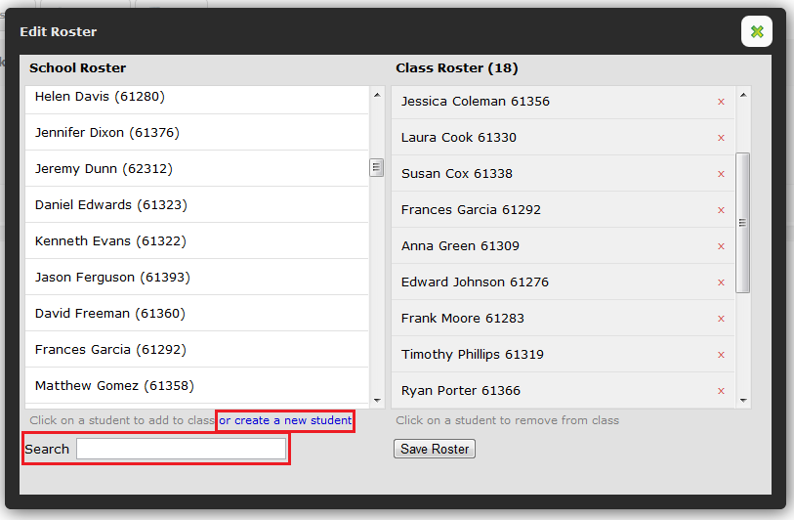
If a student is not listed on the roster, click the or create a new student link. Enter the student's first name, last name and ID number. Click the Add Studentbutton. Please note: If you do not see this option, your school likely has Strict Roster Mode enabled, and you will need to contact your school's administrator to add students to the school roster.
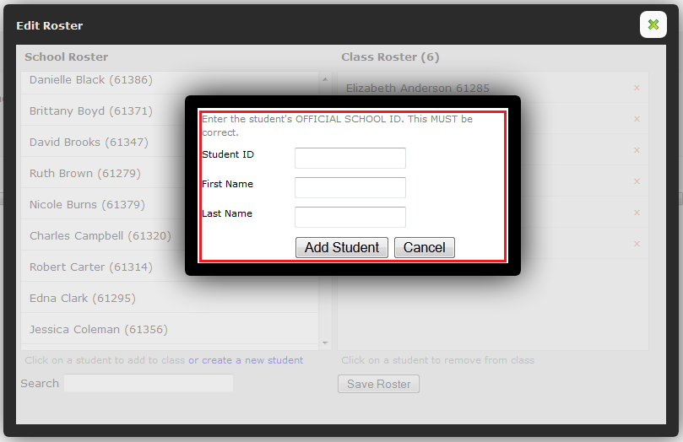
5. If you need to remove a student from your class, find the student’s name in the class roster. Click the red X to the right of his/her name. In the pop-up window, click OK to remove the student from your class.
6. When you are finished modifying your roster, click the Save Roster button.

